**Most Used Apps by Fastians**

Team Members:

Laiba Fatima 22k5195

Amal Abdul Rehman 22k4822

Sabina Rasheed 22k5198

Alizah Basit 22k5155

Bharti 22k4832

**Table of Content**

* Abstract
* Introduction
* Methodology
* Questionnaire
* Results
* Conclusion
* Recommendations

Introduction

* What?
* To investigate the most used app by students in our university and factors influencing app usage.
* Why?

Understanding app usage patterns that inform the development of effective and user-friendly apps  

* How?
* An online google form was made and distributed it on WhatsApp groups.

* When?
* 09/04/2023

* Age group?
* 18-25

1. Background: Mobile applications are an integral part of modern-day university life.
2. Purpose: To investigate the most used app by students in our university and factors influencing app usage.
3. Importance: Understanding app usage patterns can inform the development of effective and user-friendly apps.
4. Approach: Our study uses mixed-methods to provide a comprehensive analysis of app usage among university students.
5. Scope: The study focuses on identifying the most popular apps and factors influencing their use among university students.
6. Implications: The findings can inform app developers, educators, and policy makers on how to better support students through technology.
7. Significance: The study provides valuable insights into app usage among university students and its impact on their academic and social lives.

**Methodology**

* How this survey was conducted?
  + Online survey conducted by Google form
* How many person responded?
  + 30-35 people responded to this form
* How many number of questions ?
  + There are 20 questions in this
* How the survey was distributed?
  + It is distributed on different universities WhatsApp group
* Problems?
  + We didn’t receive the number of responses we expected
  + We had constantly insist people to fill up the form.

**Questionnaire**

1. What is your student ID?
2. What is your name?
3. What is your Age?
4. What is your current semester?
5. How often do you use mobile apps on your smartphone?
6. How many mobile apps do you have installed on your smartphone?
7. Which category of mobile apps do you use the most? (Select all that apply)
8. Which specific mobile apps do you use the most? (List your top 3)
9. How do you discover new mobile apps to install on your smartphone?
10. What factors do you consider when deciding to install a mobile app on your smartphone? (Select all that apply)
11. How often do you update your mobile apps to the latest version?
12. Have you ever uninstalled a mobile app from your smartphone?
13. If yes, then why did you uninstall the app?
14. How much time do you spend on mobile apps in a day, on average?
15. What are the main purposes for which you use mobile apps? (Select all that apply)
16. Do you use mobile apps for academic purposes, such as studying or accessing course materials?
17. How satisfied are you with the mobile apps that you currently use on your smartphone?
18. What improvements or additional features would you like to see in the mobile apps that you currently use?
19. How likely are you to recommend the mobile apps that you currently use to your friends or classmates?
20. Do you have any other comments or suggestions related to the use of mobile apps among university students?

**Results**

Forms response chart. Question title: How many mobile apps do you have installed on your smartphone?
. Number of responses: 33 responses. Forms response chart. Question title: How satisfied are you with the mobile apps that you currently use on your smartphone?
. Number of responses: 33 responses. 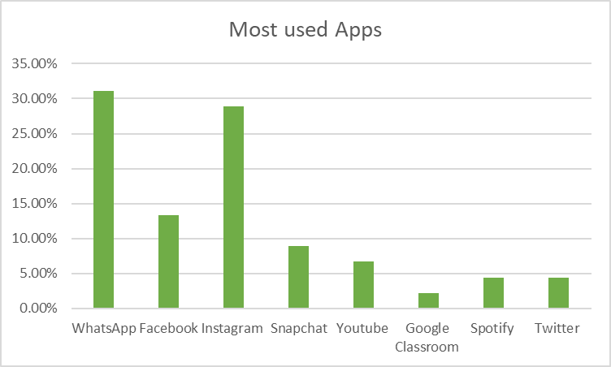 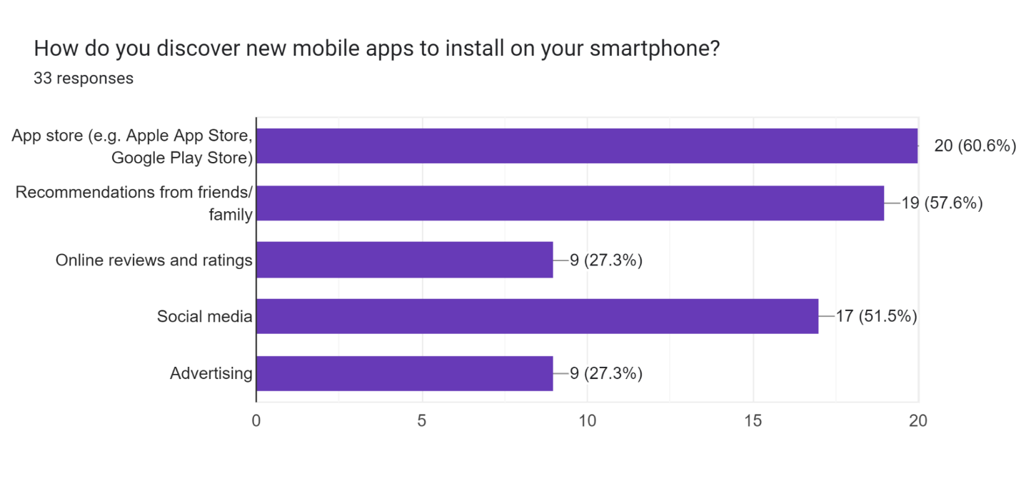 Forms response chart. Question title: What factors do you consider when deciding to install a mobile app on your smartphone? (Select all that apply)
. Number of responses: 33 responses.

**Have you ever uninstalled any app on your smartphone? If yes, then why did you uninstall the app?**

* Got bored, didn't have a usage of it anymore
* Because either I find it time consuming or boring
* If it crashes ,or if I run out of storage.
* Glitch
* Not in use for a long time.
* Google Meet, Messenger, many games
* Irrelevant Ads
* It wasn't up to the mark
* Have no good features
* Poor performance
* Become boring or useless over time
* Ran out of storage

Forms response chart. Question title: How much time do you spend on mobile apps in a day, on average?
. Number of responses: 33 responses. Forms response chart. Question title: How satisfied are you with the mobile apps that you currently use on your smartphone?
. Number of responses: 33 responses. Forms response chart. Question title: What are the main purposes for which you use mobile apps? (Select all that apply)
. Number of responses: 33 responses. **What improvements or additional features would you like to see in the mobile apps that you currently use?**

* None
* Google Classroom could be more better
* Offline availability
* In C compiler additional features must be there
* Performance
* Satisfied .
* I wish the apps weren't so laggy.
* Response time
* WhatsApp: call option on whatsapp web
* Bug fixes
* More user friendly
* As users like to have control over the look and feel of the app they are using so some more customization options , should be provided such as themes and new fonts.
* There should be no country specific restrictions
* Efficiency and free for students
* Less advertisements
* Nice UI
* Restricted screen time

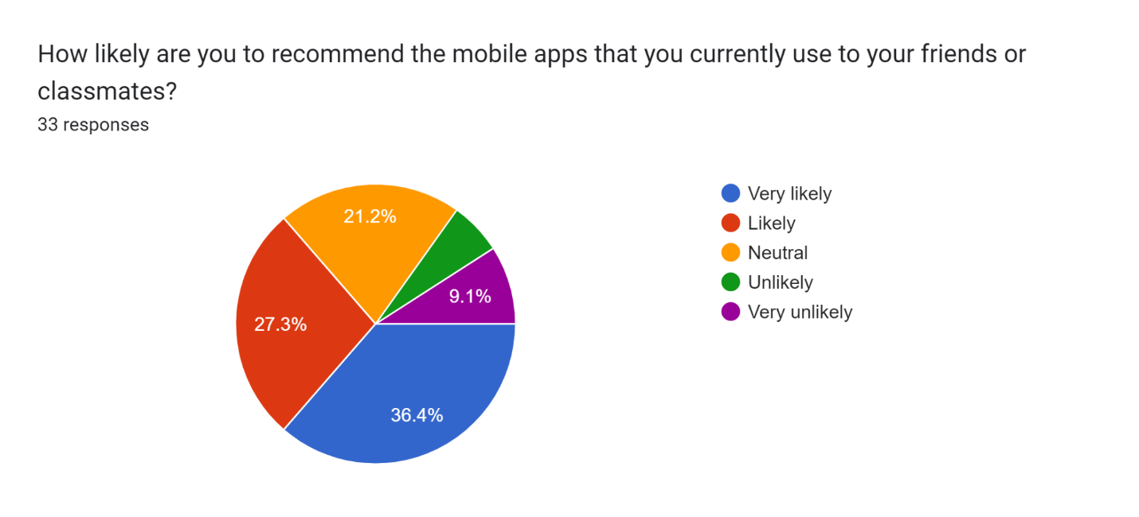 **Do you have any other comments or suggestions related to the use of mobile apps among university students?**

* Should be used within the limits.
* Students should explore some educational apps that are related to their courses . As university students have busy schedule so they should use some effective time management and productivity app that can help them stay organize manage their workload Balancing screen time with other activities can help reduce stress and improve overall health. While mobile apps can be helpful, it's important for students to take breaks from using them and engage in other activities that promote mental and physical well-being.
* Even though I don't use them productively, they should be used in a productive way.
* No thanks

**Conclusions**

**What this survey found….**

1. Most used apps

* Instagram
* Whatsapp
* Youtube

2. Purpose for using these apps

* Social networking
* Education and learning
* Productivity and Entertainment

3. Benefits of using them

* Time management
* Personal interest
* Productivity increases
* Educational Purpose

4. Number of apps installed

* About 39% students have 10 to 20 apps
* About 21 % students have 20 to 30 apps
* 12 % have less than 10 apps
* Rest have more than 30

5. Time spent

* Maximum spend more than 3 hours
* 12.1% psend 2 to 3 hours mostly
* 12.1% spend 1 to 2 hours only

Time Management

Students reported using apps to manage their daily schedules.

Installation

Student consider apps based on their features and functionality, ratings and suggestions from friends .

Students Suggestions

Most of the students suggested to not rely on these mobile apps and use them in limits

Discovering Apps

Through reference from friends, online ratings and  social advertising